Where did all these kids come from?

Despite some families leaving for the suburbs during COVID, the District’s youth-age population is 10% higher now than it was in 1990, and 22% higher than it was in 2010. This makes us unlike many other major U.S. urban areas, which, according to a recent Wall Street Journal analysis of Census Bureau data, saw their youth-age populations drop 6% on average. Nationwide, the youth population declined 1%. This post explores why DC has been an exception to this trend.

Takeaways:
- In the mid-20th century, the District had many more children than it has today.
- A significant share of the 2010s growth in DC’s youth population is a return to the child population DC had around 1995.
- Some of DC’s 2010s child population growth came from more births. That happened because more adults of childbearing age lived here, not because fertility rose (it fell).
- Child net out-migration also shrank during the 2010s: relatively more families with children moved into DC, and fewer moved out. That said, net migration remained negative at every child age during the 2010s (it just became less negative than in, say, the 2000s).
- Roughly a third of the swing from population decline in the 2000s to growth in the 2010s came from a smaller cohort aging out, a legacy of the 2000s’ low point in youth population.
- The population gains were concentrated among Hispanic, non-Hispanic White, and higher-income families. The number of Black children fell.

Youth history
First, let’s quickly compare DC to its own past, and to other U.S. urban areas.
DC has experienced a recent uptick in its youth population, even with a COVID-induced dip.
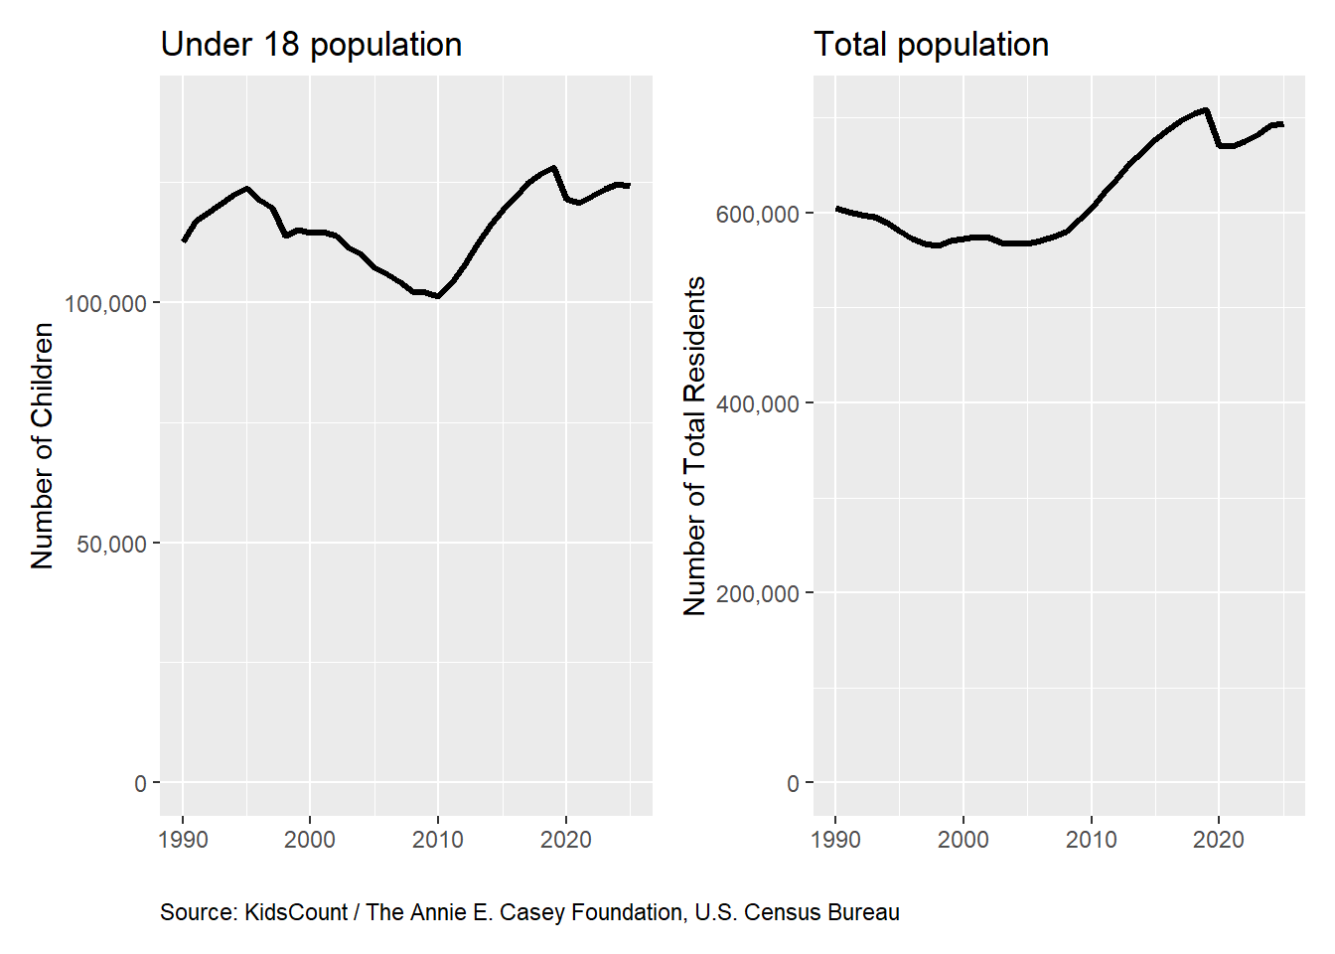

But by broader historical standards, our youth population is somewhat low. DC’s total population peaked in the mid-20th century—and there were almost twice as many kids living in the District back then. In 1960, one in four DC residents were under age 15.

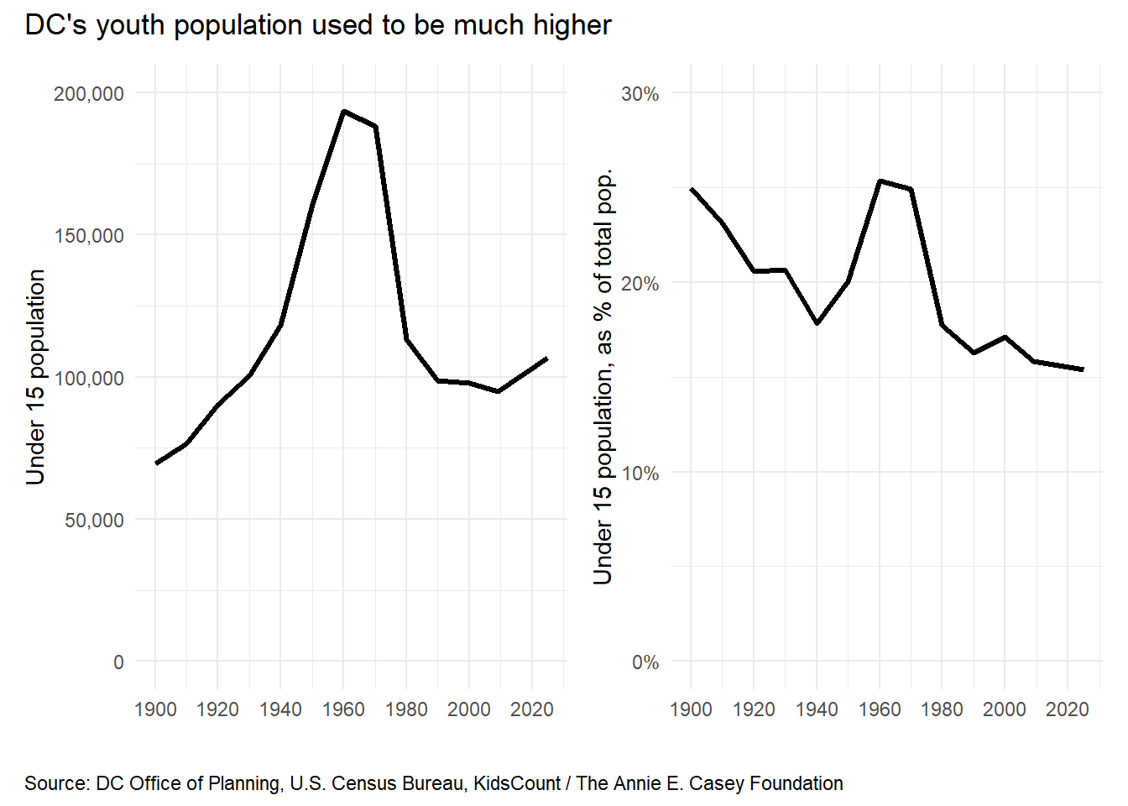

In the latter half of the 20th century, DC’s child population cratered, as many White families (and, later, Black families) decamped to the suburbs. Relative to other urban areas, DC has relatively fewer children. The chart below shows the percentage of residents in large urban counties that are under age 18. DC is near the bottom.
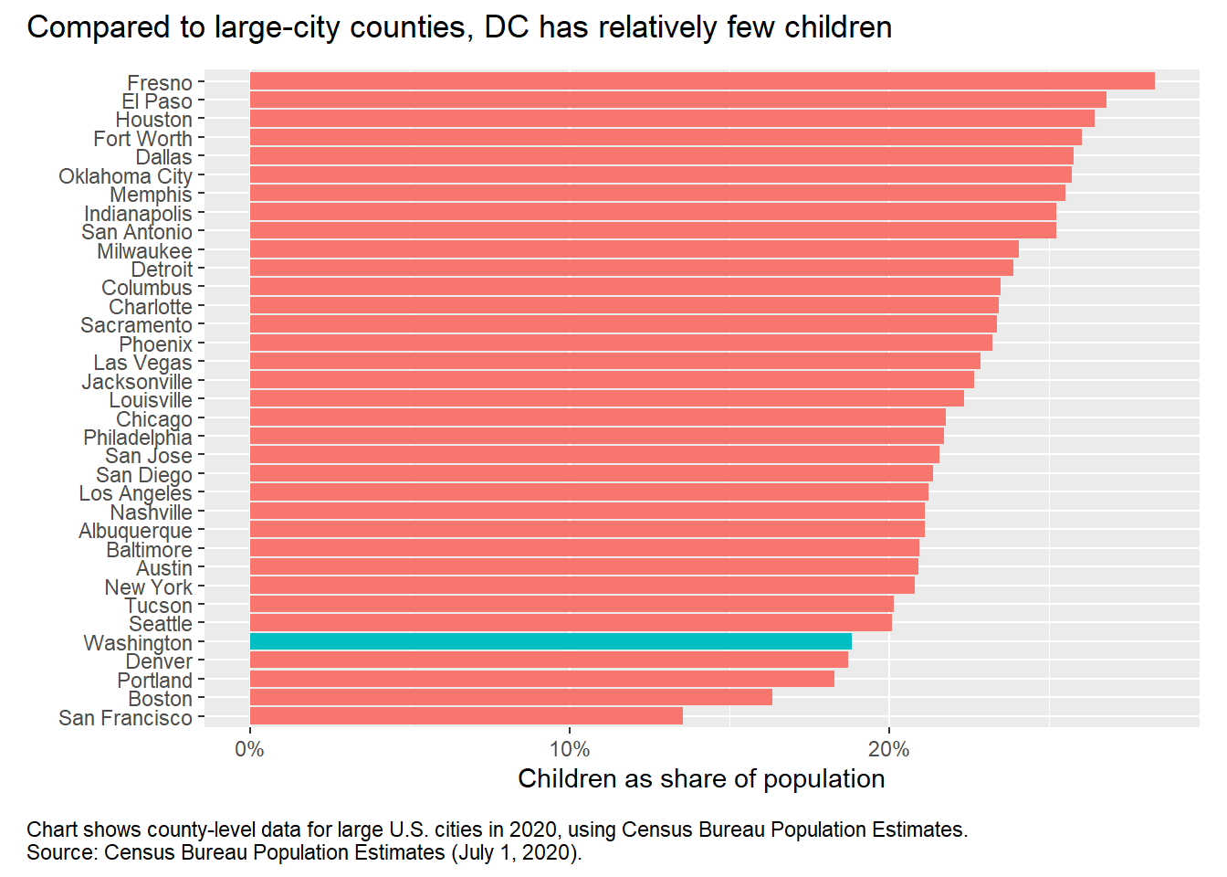

March of the Tots

Much of the recent increase in the District’s youth population has been concentrated among very young children (under age 5), although older age groups (between ages 5 and 12) saw population increases between 2010 and 2020.

Age group | 2000 population | 2010 population | 2020 population | ’00 - ’20 change
under 3 | 19,276 | 20,551 | 22,543 | 3,267
3 but under 5 | 13,260 | 12,062 | 14,525 | 1,265
5 but under 7 | 13,868 | 10,858 | 13,619 | -249
7 but under 9 | 14,346 | 10,160 | 13,378 | -968
9 but under 11 | 14,154 | 10,155 | 12,730 | -1,424
11 but under 13 | 11,875 | 9,828 | 11,723 | -152
13 but under 15 | 11,160 | 10,187 | 10,786 | -374
15 but under 17 | 11,193 | 11,006 | 10,106 | -1,087
Source: U.S. Decennial Censuses for 2000, 2010, and 2020. Totals may differ from those shown in the charts above, which are based on Census’ Population Estimates. Those estimates better account for undercounting of youth populations.

But why are there more children?

The clever people at the University of Wisconsin’s Applied Population Laboratory use a combination of Census data and birth and death records to decompose youth population changes in American states into three causes:

- Births
- Children aging out of childhood (they grow up so fast!)
- Net migration

Each of these explains roughly 1/3rd of DC’s recent youth population increase. Let’s take each in turn.

(A quick methodology note: APL bins people into five-year age groups, so 0–14 is the last age bracket that does not include adults. The next group up, 15–19, mixes children with college-age adults. For this reason, we end the “child” groups at age 14 in the analysis below.)

The chart below shows how each of these three factors added or subtracted from DC’s population between 2010 and 2020. Overall, child net migration was negative (-17,800). In other words, more children moved out of DC than moved into DC. The age-out term will always be negative; roughly 51,100 people who were children in 2010 were 15 or older by 2020. But these subtractions were outweighed by births (+93,200), so the total youth population was roughly 24,300 higher by the end of the decade.

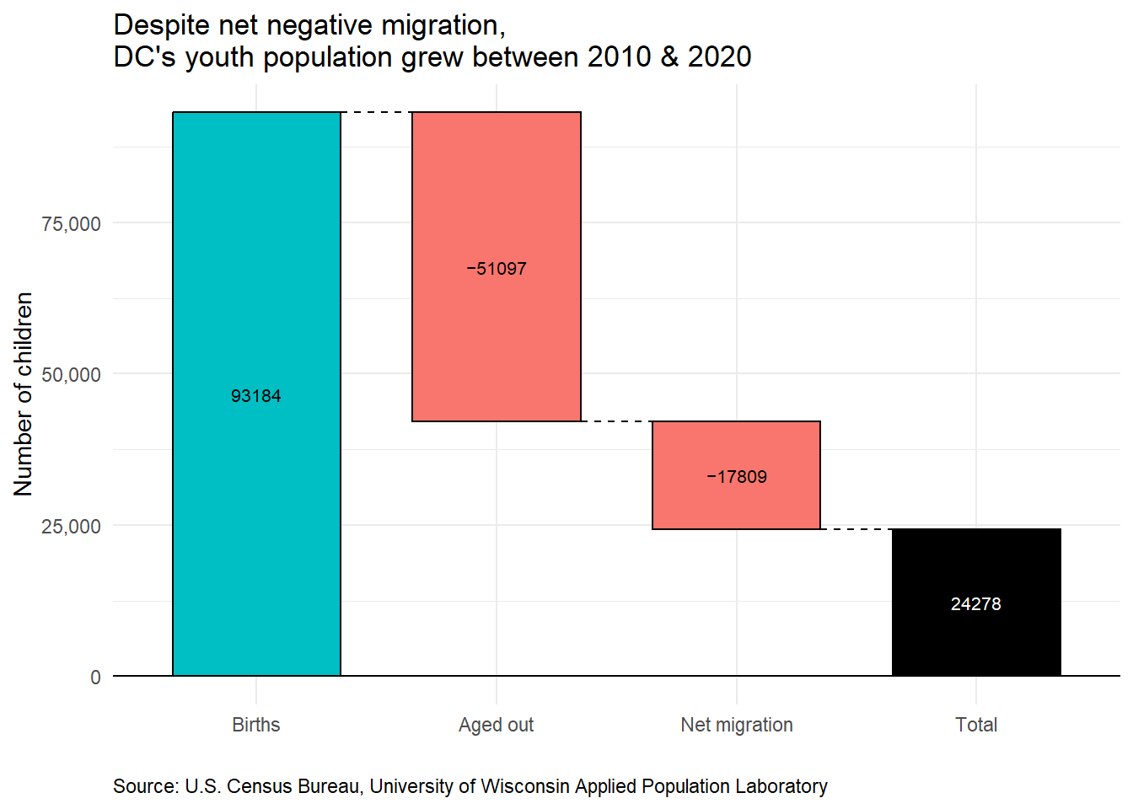

The sections below unpack each of these three contributions to the District’s 2010s youth population increase.

Births
DC’s overall population increased during the 2010s. All else equal, adult population increases will lead to youth population increases, because some of those additional adults will have children. Indeed, births in DC increased during the 2010s, relative to the 2000s. Note however, that the number of births during the 1990s was comparable to the number during the 2010s: 92,816 versus 93,184, respectively. So in one sense, 2010s births were more of a return to 1990s levels than a novel increase (although as discussed below, the demographics of the 2010s increase are different).
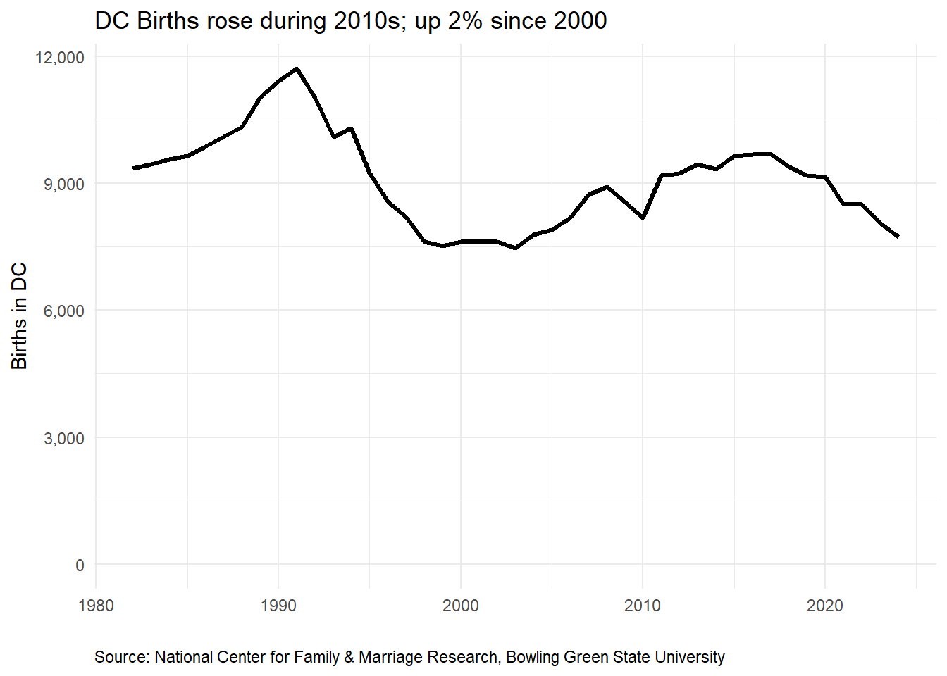

Part of the increase in births during the 2010s can be traced to a specific driver: net in-migration of people in their 30s increased significantly during the decade. There were more people living in DC at the age when many people start families. The line chart in the net-migration section below shows how net migration changed across all age groups over the decades in DC. Note the upward jumps in the 25-39 groups.
There was also a significant drop in infant mortality in DC between the 2000s and 2020. According to the DC Department of Health, there were roughly 8 deaths per 1,000 live births in DC in the early 2010s; this fell to 5.5 deaths per 1,000 live births in the 2019-2023 period. While this is a huge improvement (and literally a matter of life and death!) it accounts for a relatively small share of DC’s total population increase during the 2010s. A drop in infant mortality of 2.5 deaths per 1,000 live births represents roughly 233 additional births, using the 2010s-era 93,184 births as a baseline. That’s about 0.25% of all births during that period. While this drop in infant mortality is obviously a good thing, it is not a major driver of DC’s 2010’s population increase.
It is also worth noting that the rise in births wasn’t due to an increase in the fertility rate (i.e. the likelihood that a given person decides to have children). DC’s fertility rate has fallen almost every year since the mid-2000s, which itself represented a decline from the early 1990s. Demographers calculate the “general fertility rate” by dividing the number of births by the female population ages 15 to 44, and multiplying by 1,000. The chart below shows DC’s GFR over time. This has steadily fallen.
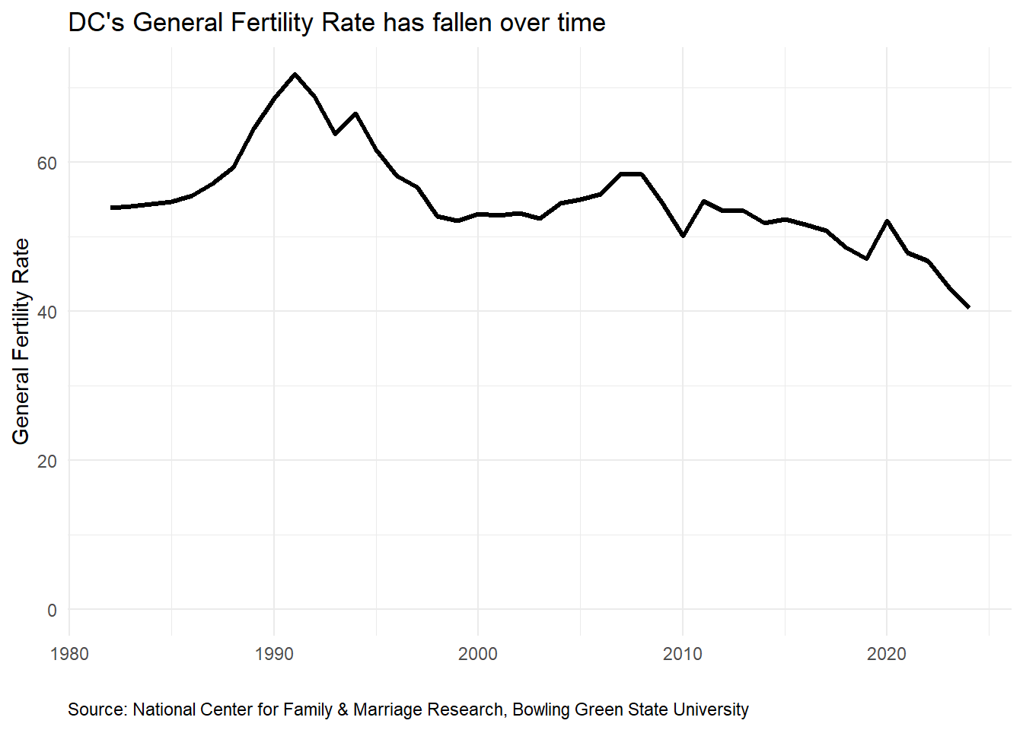

DC’s GFR is also on the lower end among large U.S. cities.

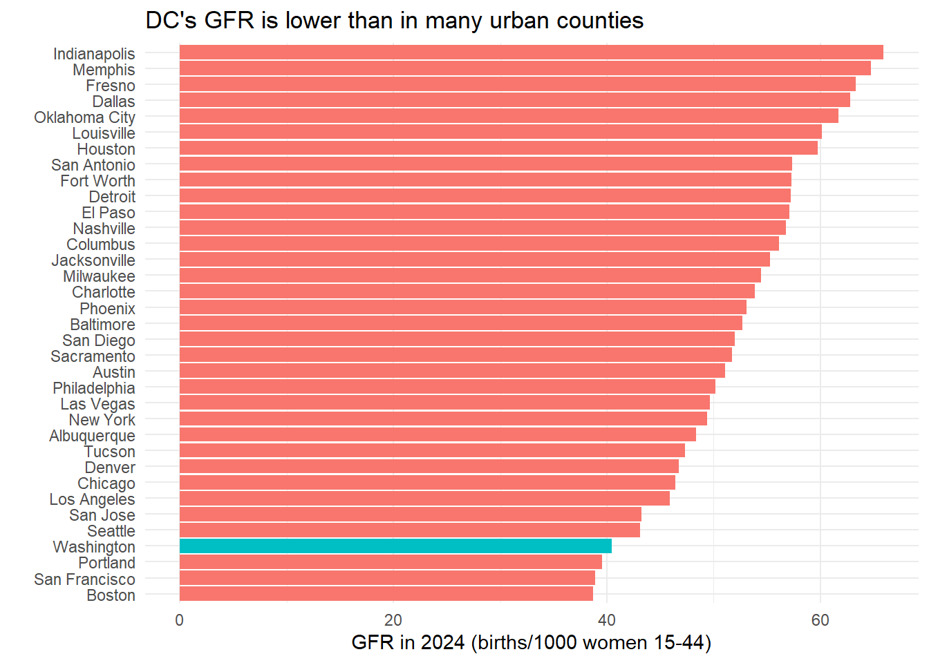

Net Migration
The line chart below, based on APL analysis, shows how the 2010s saw less negative youth net migration, though it was still negative for all under-15 groups. Again, note that net migration for people in their late-20s and 30s increased; these are the age groups when people tend to have children. (Net migration for 20-somethings has been positive for the last three decades, as young adults attend university or start a first job).
It is possible that some of the increase in net-migration among very young children is due to policies like universal pre-kindergarten; in analysis not shown here, we attempt to test this hypothesis, by comparing migration rates for very young children to migration rates for pre-teens, whose migration rates would theoretically be less impacted by the pre-k policy change. We do not observe a divergence in migration rates between the two groups, but the data are quite noisy, so it is difficult to draw any real conclusions from the data.

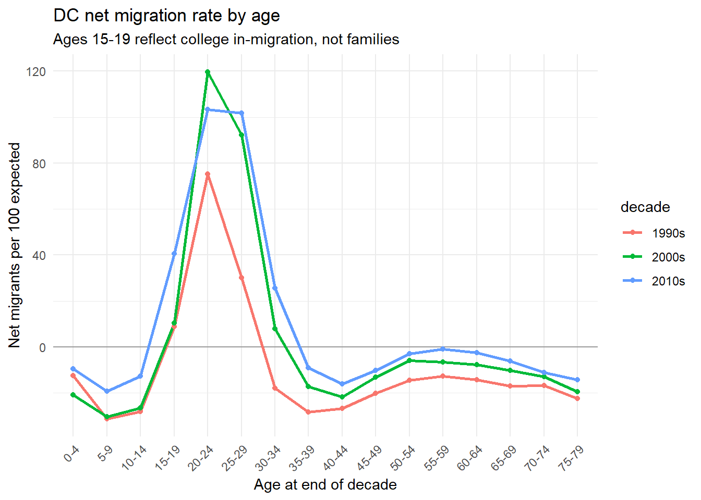

Children aging-out
If you refer to the second chart in this report, you will notice that 2010 marked the lowest point in DC’s youth population in the last 85 years. In other words, there were not that many children, relatively speaking, living in DC in 2010. This means that any increase in the child population after 2010 would look proportionately larger than if the initial child population had been bigger in 2010. This is sometimes called the “low base effect.”
In this case, the relatively small number of children in 2010 also means, mechanically, that there were fewer children in the 2010s aging past 14. So some of the large 2010s increase in DC’s youth population appears because there weren’t as many existing children aging out of childhood. Put another way: if there had been a much larger number of youth in DC in 2010, that had then aged past 14 by 2020, this would look like a big decline in the youth population, even if the number of births and net migration were held constant.

Putting it all together
The chart below compiles the APL estimates to how much each of these three factors contributed to the total net change in youth population in DC, by decade. As discussed above, more births, fewer age-outs, and less negative net migration each accounted for roughly a third of the swing from youth population decline in the 2000s to growth in the 2010s.
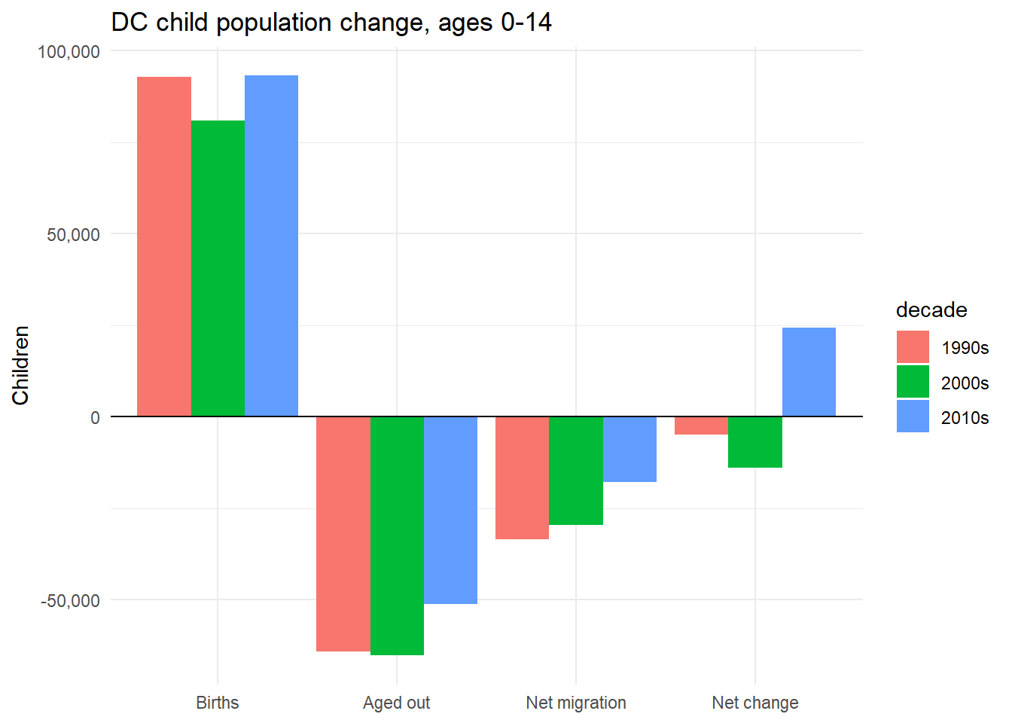

Decomposing youth population changes: race
The sections above tell a broad statistical story about why the District’s youth population increased during the 2010s. The next two sections break down this increase along race and income lines.
While the numbers of Hispanic and Non-Hispanic White children have risen in DC since 2010, the number of Black children has continued to fall. (Note that the totals shown below differ slightly from some of the charts above, which are based on Census’ Population Estimates. Again, those estimates better account for youth undercounts in the Decennial Census).
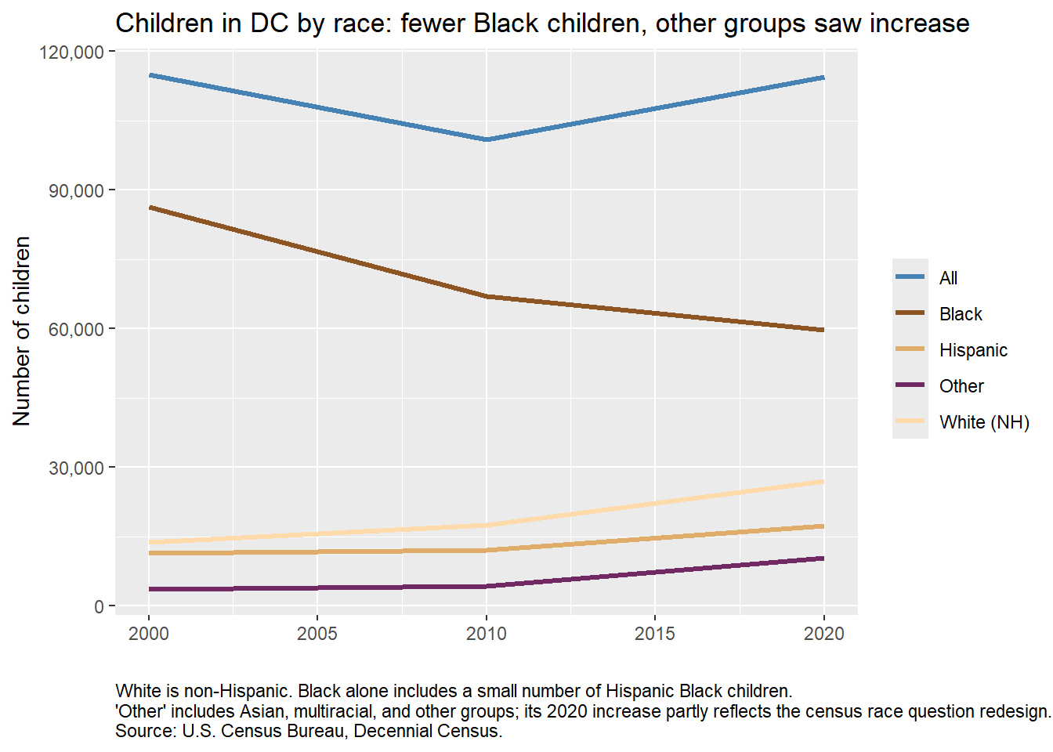
Part of what is happening here is that non-Hispanic White parents were more likely to move to the District than they were 40 years ago (or remain in DC, if they were existing residents). This would be part of a broader trend: the reversal of white flight in large U.S. urban areas. Meanwhile, higher housing costs have led (or financially forced) many Black residents to move to the suburbs.
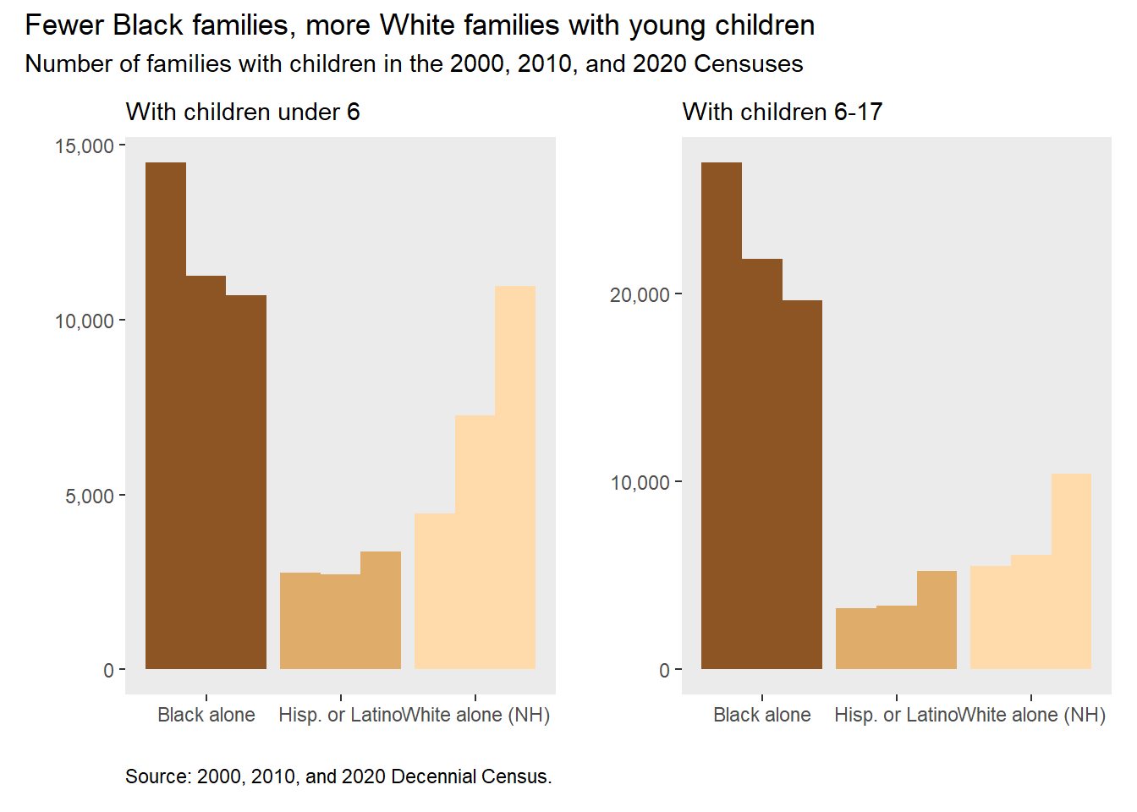

Decomposing youth population changes: income
The average District youth is now also more likely to come from a high-income family. Since the mid-2000s, the proportion of DC children in higher-income families rose from 10% in 2007 to 20% in 2024.
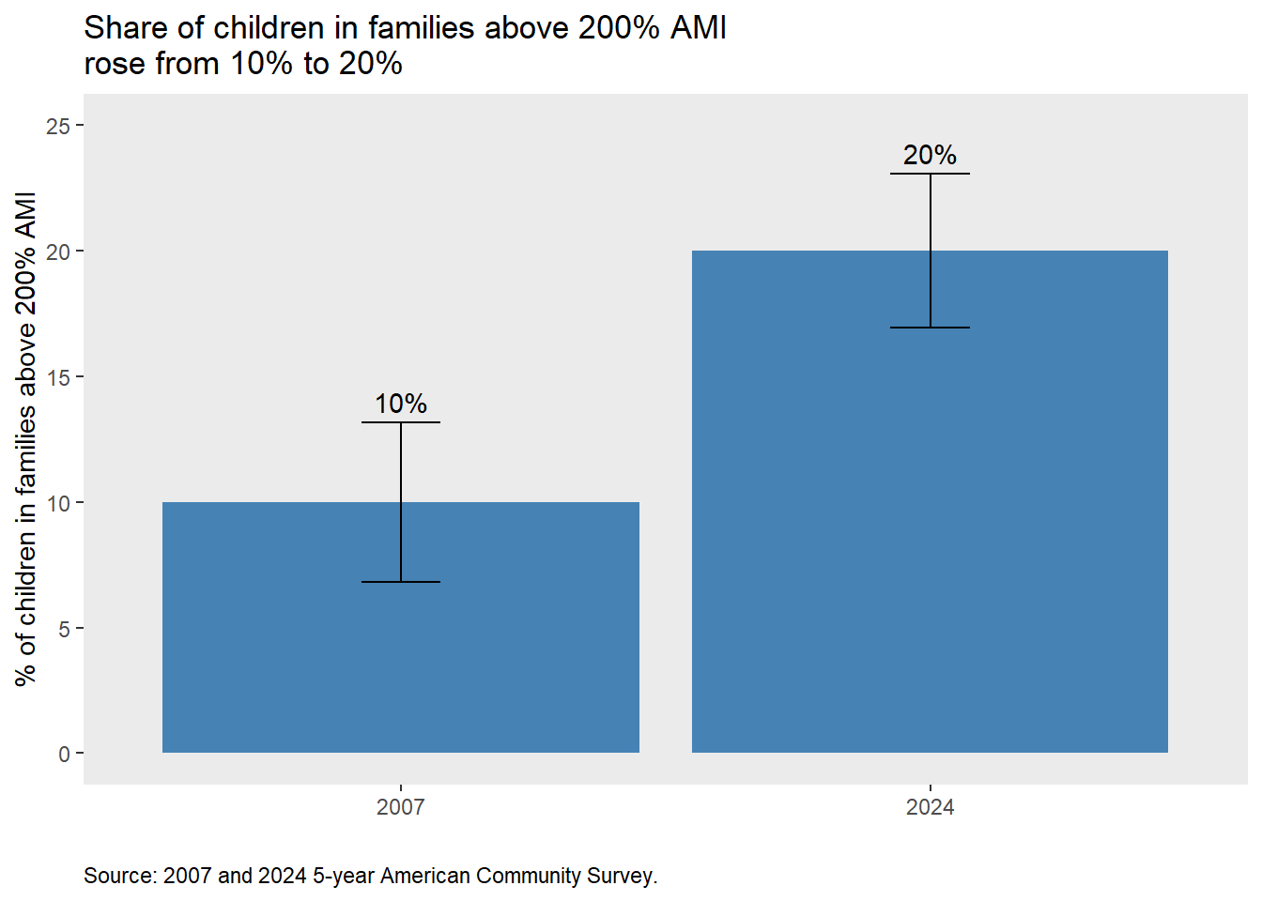

Data from individual income tax filings, charted below, show a similar trend. The upper quintile of households increasingly represent a larger share of children in the District.

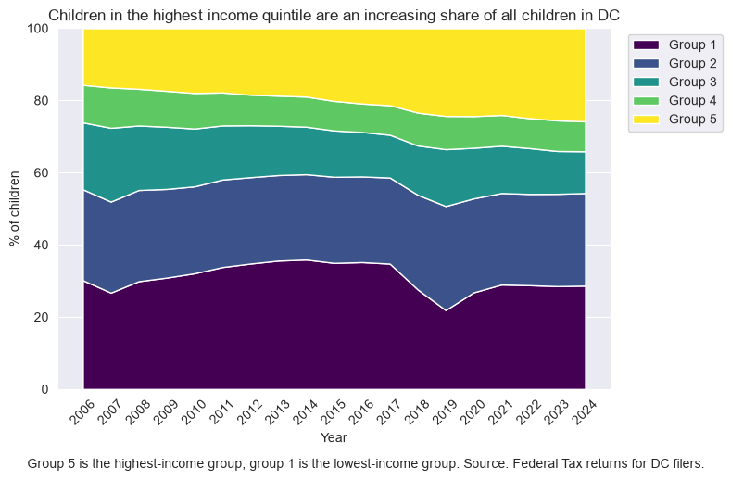

In summary
- In the mid-20th century, the District had many more children than it has today.
- A significant share of the 2010s growth in DC’s youth population is a return to the child population DC had around 1995.
- Some of DC’s 2010s child population growth came from more births. That happened because more adults of childbearing age lived here, not because fertility rose (it fell).
- Child net out-migration also shrank, though it remained negative at every child age.
- Roughly a third of the swing from population decline in the 2000s to growth in the 2010s came from a smaller cohort aging out, a legacy of the 2000s’ low point in youth population.
- The population gains were concentrated among Hispanic, non-Hispanic White, and higher-income families. The number of Black children fell.

